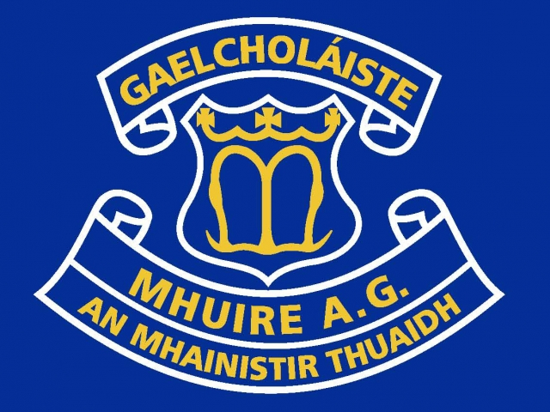 

**MEAS**

**& Iarracht**

**8.15 – 8.30: Club bricfeasta** - optional breakfast available to all all students.

**8.30 – 8.40: Ullmhú dos na ranganna –** students organise themselves for classes.

**8.40 – 10.40: Rang 1-3**

**10.40 – 10.55: Sos (Break)**

**10.55 – 12.55: Rang 4-6**

**12.55 – 13.25: Lón (Lunch)**

Fanann daltaí 1AG ar scoil don lón. 1AG Students remain at school for lunch break.

**13.25 – 15.25: Rang 7-9**

**Leagan Amach an Lae**

**Ceannaire Bliana – Year Head**

Michelle Ní Mhurchú

**How can I, as a parent/guardian, help with the transition from Primary to Secondary?**

* **Eagrúchán – Organisation - Stationary, Copybooks, Folders, Labels, Homework Space, P.E. Days.**
* **Tnútháin – Expectations - Encouragement and Support to achieve**
* **Eischuraclair – Extra-Curricular - Encouragement to partake and to try new things**
* **Tinreamh & Poncúlacht – Attendance & Punctuality**
* **Cumarsáid – Communicate!!**

# Fáilte romhaibh, a thuismitheoirí!

### An Lá Scoile

1AG 2019-20

* **Please see letters re: payments.**
* **1st Year Induction Day – August 23rd 2019**
* No ‘Group Chats’ are set up or monitored by Gaelcholáiste Mhuire A.G.
* Be aware of which Social Media Apps students are using
* WWGS – What would Granny say?!
* Monitor… Watch out for changes of behaviour..
* Time… Addiction to Social Media…Sleep
* Friends & Followers - Privacy/Location Settings
* Screenshot inappropiate/offensive content
* Think Twice before you send/click…
* Communication

**What’s next?**

**1) Tinreamh – Attendance:**

* Monitored closely by the year head.
* Absences must be explained in writing with a note on return.
* If a student is absent for three days without notice from the parent/guardian, the school will make contact.
* Letter – 10 lá ……….. NEWB – 20 lá
* Awards – Recognition for Attendance

**2) Poncúlacht - Punctuality**

* Aim to be in school before 8.30a.m.
* Punctuality during the school day also important
* Explanation in writing in the school diary if a student is late
* Pattern….

**3) Éide Scoile – Uniform**

* School uniform must be worn. Tracksuit on P.E. & Match Days only.
* Note of explanation in school diary if there is a uniform issue.

**4) An Ghaeilge:**

* Is Gaelcholáiste í an scoil seo
* Iarracht a dhéanamh – make an effort
* Meas ar an dteanga – respect for the language
* Béim ar chumarsáid leis na múinteoirí as Gaeilge – communicate with teachers through Irish
* Tacaíocht - Support

**5) Obair Bhaile**

* An Dialann – Homework assigned will be on the Homework board in the classroom for students to write in their diary.
* Obair bhaile éagsúil – written, reading, research, learning, project, diagrams – All Homework!!!
* Cumarsáid – communicate issues to teachers - school diary.
* Freagracht – Responsibility

As Láthair nó Ar Ghnó Scoile (extra-curricular) – faigh an obair bhaile…

**Na Meáin Shóisialta – Social Media**

## Ár gCaighdeáin – Our Standards